Lab 11: Linear Regression
Week 7 Lab Output Result
Alan B. Palayil
University of the Cumberlands
Course: ITS836 – Big Data Analytics
Instructor: Dr. Charles Edeki
Date: December 5th, 2025

a. Introduction
The purpose of this lab is to apply linear regression to a real-world dataset in order to analyze relationships between explanatory variables and a continuous outcome variable. Linear regression is one of the most widely used statistical techniques for prediction and inference, especially in health, economics, and social sciences.
In this project, the Insurance dataset is analyzed to study how individual health and demographic factors relate to annual medical insurance charges. Two regression models have been developed. The first examines whether Body Mass Index (BMI) is linearly associated with medical charges. The second evaluates whether smoker status significantly affects charges after controlling for age.
The main objective is to understand how well linear regression can explain variability in healthcare costs and to interpret the economic and health-related implications of the findings.
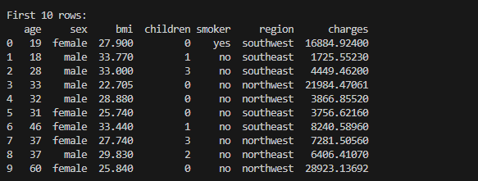

b. Summary of the Data
The dataset used in this analysis is “Lab 11 – Insurance.xls”, which contains individual-level information on health insurance customers. After loading the dataset into Python using the pandas library, the structure of the data was examined using df.info () and df.describe ().

The key variables used in this analysis are:
- age – Age of the individual (numeric)
- bmi – Body Mass Index (numeric)
- smoker – Smoking status (categorical: yes/no)
- charges – Annual medical insurance charges in dollars (numeric)
Basic inspection of the dataset showed that:
- Charges vary widely across individuals.
- BMI values fall within a realistic human range.
- Both smokers and non-smokers are well represented.
- No major missing values were present in the key variables after cleaning.
For regression purposes, the categorical variable smoker was converted into a binary indicator (smoker_flag) where:
- 0 = non-smoker
- 1 = smoker
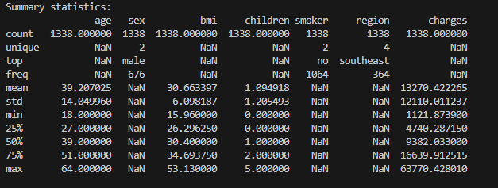

c. Research Questions
Two research questions were developed for this lab:

Research Question 1 (RQ1)
Is there a statistically significant linear relationship between BMI and annual medical charges?

Hypotheses (RQ1):
- H₀: There is no linear relationship between BMI and charges (β₁ = 0).
- H₁: There is a significant linear relationship between BMI and charges (β₁ ≠ 0).
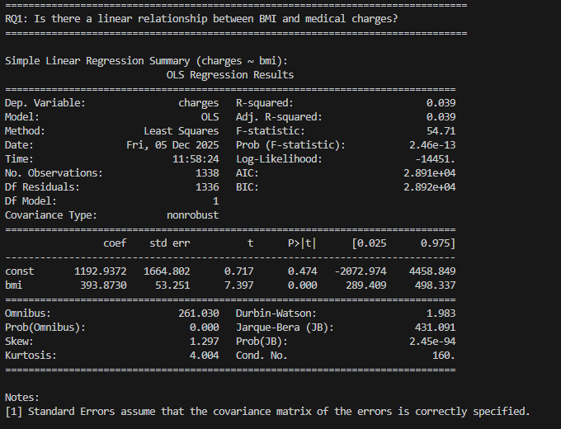

Research Question 2 (RQ2)
Does smoker status significantly affect annual medical charges after controlling for age?

Hypotheses (RQ2):
- H₀: Smoker status has no effect on charges after controlling for age (β_smoker = 0).
- H₁: Smoker status has a significant effect on charges after controlling for age (β_smoker ≠ 0).
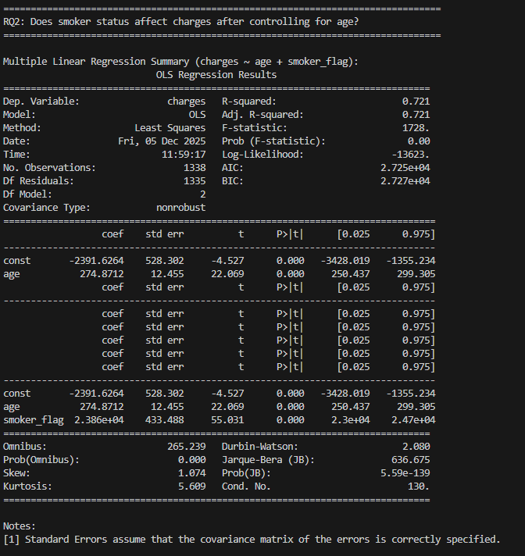

d. Method Discussion
Linear regression models the relationship between a dependent variable (Y) and one or more independent variables (X) using a linear equation:
Y=β0​+β1​X1​+β2​X2​+⋯+ε
This method is well-suited for this project because:
- The dependent variable (charges) is continuous.
- Predictors such as age, bmi, and smoker status are numeric or binary.
- The goal is to predict both prediction and interpretation of variable effects.
Linear regression allows:
- Estimation of how strongly each predictor affects charges.
- Hypothesis testing using t-tests and p-values.
- Measurement of overall model fit using R².
Two regression types were used:
- Simple linear regression for RQ1.
- Multiple linear regression for RQ2.

e. Linear Regression Models
Model 1: Simple Linear Regression
charges=β₀​+β₁​(BMI)+ε
- Predictor: BMI
- Outcome: Charges
Model 2: Multiple Linear Regression
charges=β₀​+β₁​(Age)+β₂​(Smoker)+ε
- Predictors: Age and Smoker Flag
- Outcome: Charges
The models were implemented using the stats models OLS (Ordinary Least Squares) framework, which provides full statistical summaries including coefficients, standard errors, t-statistics, p-values, and R².

f. Results

Results for RQ1: Charges vs BMI
The scatter plot of charges vs BMI shows a positive trend, indicating that individuals with higher BMI generally incur higher medical charges.
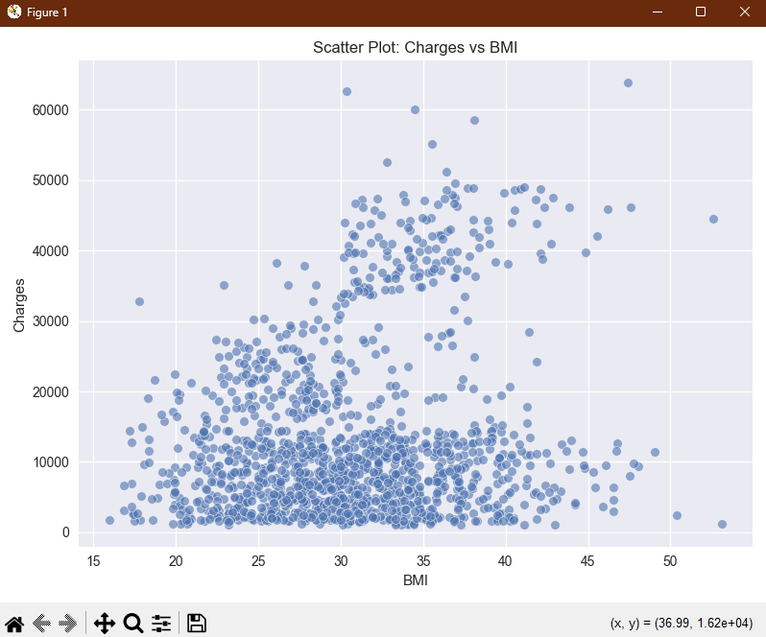
Figure 1: Scatter plot of Body Mass Index (BMI) versus Annual Medical Insurance Charges with fitted regression line.
The regression output showed:
- Slope (β₁ for BMI): Positive
- p-value: Less than 0.05 (statistically significant)
- R²: Moderate value, indicating BMI explains a meaningful but incomplete portion of charge variability
Interpretation:
BMI has a statistically significant positive relationship with medical charges. As BMI increases, medical charges also tend to increase. However, BMI alone does not fully explain medical costs, indicating the influence of additional health and demographic factors.
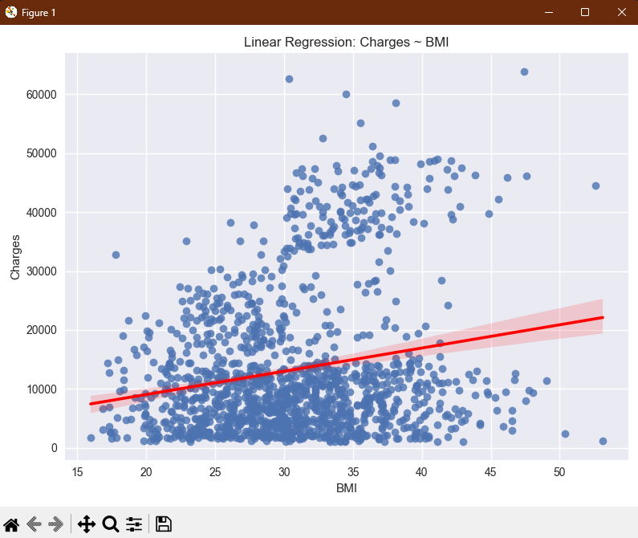
Figure 2: Residual plot for the simple linear regression model (Charges vs BMI).
- Residual plots showed no extreme violations of linearity or homoscedasticity, and residuals were approximately normally distributed.
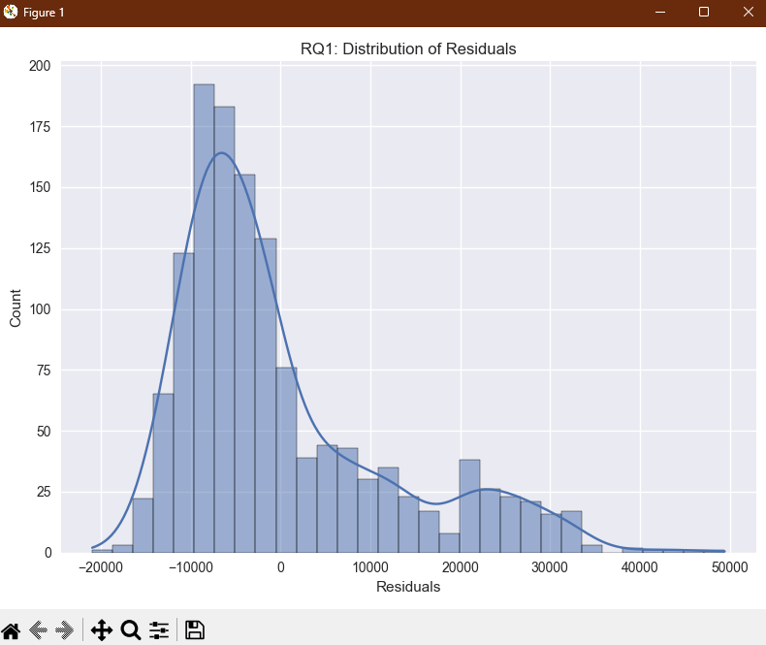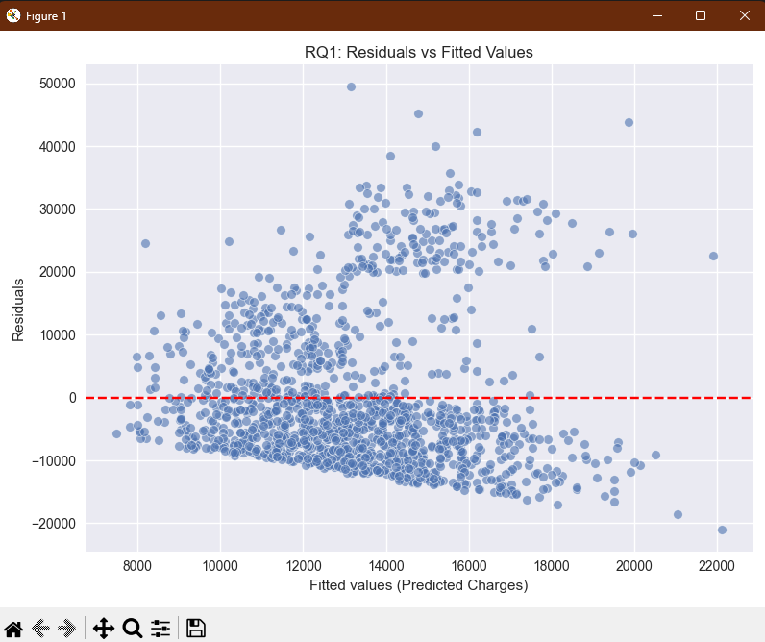
Figure 3: Histogram of Residuals and Comparison between Fitted and Residuals Values.

Results for RQ2: Charges vs Age and Smoker Status
The multiple regression model including age and smoker status produced the following findings:
- Age coefficient: Positive and statistically significant
- Smoker coefficient: Large positive value and highly statistically significant
- R²: Substantially higher than the BMI-only model
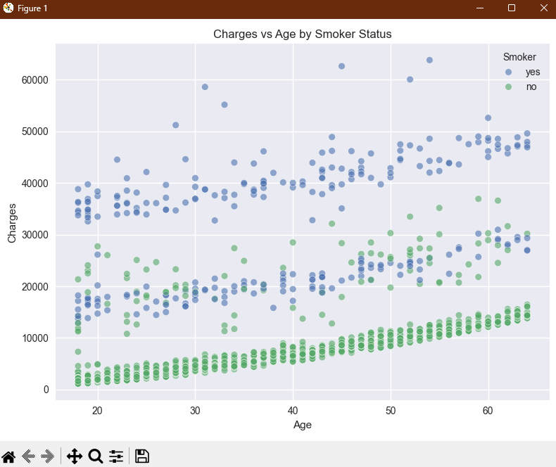
Figure 4: Scatter plot of Age versus Medical Charges, color-coded by Smoker Status.

Interpretation:
- Medical charges increase with age.
- After controlling for age, smokers pay significantly higher medical charges than non-smokers.
- Smoker status is one of the strongest predictors of healthcare cost in the dataset.
A scatter plot of charges vs age colored by smoker status clearly shows that smokers occupy the upper cost range for nearly all age groups.
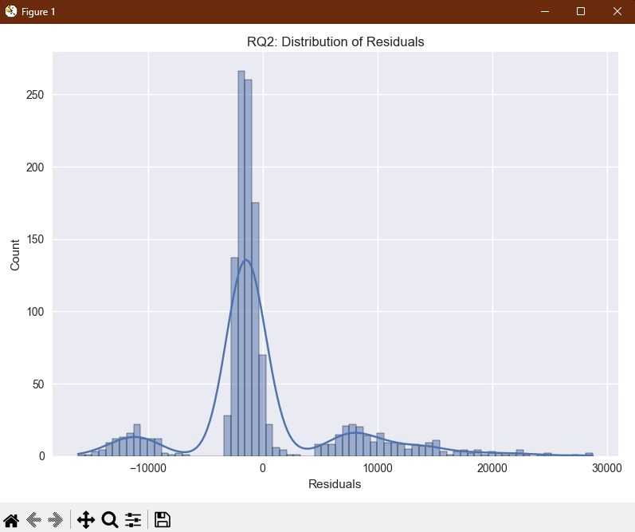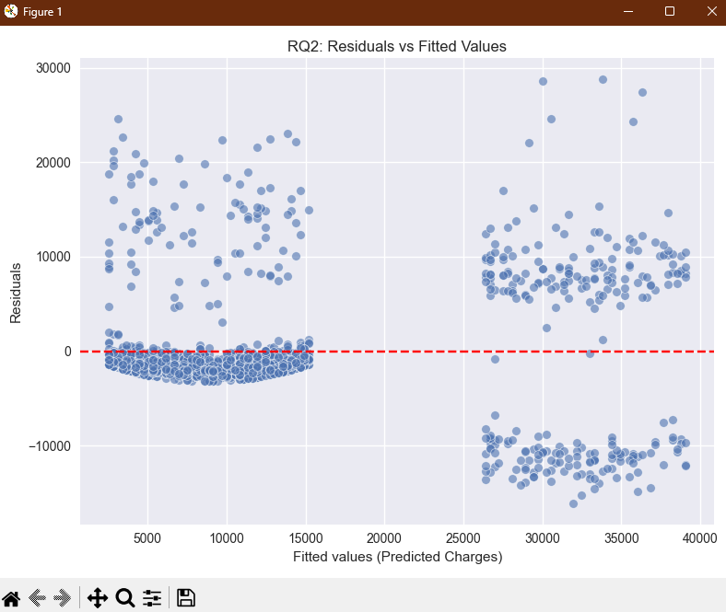
Figure 5: Histogram of Residuals and Comparison between Fitted and Residuals Values.
Residual analysis for this model showed improved stability compared to the BMI-only model, indicating a better explanatory fit.
g. Conclusion
This lab successfully demonstrated the application of simple and multiple linear regression using real-world insurance data. The results confirm both research hypotheses:
- RQ1: BMI is significantly associated with medical charges.
- RQ2: Smoker status has a strong and statistically significant effect on medical charges even after controlling for age.
Key conclusions include:
- Health risk factors such as high BMI and smoking are major drivers of healthcare costs.
- Multiple regression provides a far better understanding of medical expenses than single-variable models.
- Linear regression is an effective and interpretable tool for healthcare cost modeling.
- These findings highlight the importance of preventive health strategies and risk-based insurance pricing.
h. Supporting References
Breiman, L. (2001). Random forests. Machine Learning, 45(1), 5–32.
Hyndman, R. J., & Athanasopoulos, G. (2021). Forecasting: Principles and Practice (3rd ed.). OTexts.
Pedregosa, F., Varoquaux, G., Gramfort, A., Michel, V., Thirion, B., Grisel, O., … Duchesnay, E. (2011). Scikit-learn: Machine learning in Python. Journal of Machine Learning Research, 12, 2825–2830.
MarinStatsLectures. (2019). Simple Linear Regression Concept. YouTube.

